**WFA 8223 Management of Impounded Rivers**

2020-01-15

Summary and discussion of:

Ensign, Scott H. and Martin W. Doyle. 2006. Nutrient spiraling in streams and river networks. *Journal of Geophysical Research*, 111:G04009, doi: 10.1029/2005JG000114.

**Scott H. Ensign** is an Assistant Director and Research Scientist at the Stroud Water Research Center in Avondale, PA. Before his current appointment, Dr. Ensign held a variety of positions in academia and private industry. He is extensively involved as a reviewer for over 20 journals, including *Freshwater Science*, *Nature Geoscience*, and *Ecology*, and the National Science Foundation, Sea Grant. With over 30 publications and more than 50 presentations, he has extensive knowledge on how plants, animals, and microbes interact with rivers, especially biogeochemically, and how such interactions influence society.

**Martin W. Doyle** is Professor of River Systems and Policy and Senior Associate Dean for Academic and University Initiatives at Duke University. Dr. Doyle has held appointments within the Federal Government, including the Department of the Interior and U.S. Army Corps of Engineers. Much of his work focuses on river ecosystem services and their interaction with policy and markets. Among his many works are a book, *The Source*, which provides an interesting perspective on how rivers in the U.S. have shaped society and economy; and highly impactful (300+ citations) articles on biogeochemical movement in flowing waters and the effects of restoration efforts, such as dam removal.

**Significant Points.** What is the role of the stream network in nutrient spiraling and export to lentic and marine systems?

**1. Introduction.** Nitrogen (N) and phosphorus (P) are the building blocks of aquatic ecosystems, allowing plant life to respire and grow. However, when these building blocks occur in excess fundamental changes in the system can occur (e.g., eutrophication). To manage such changes, it is important to understand how streams and rivers import excess nutrients to lakes, estuaries, and coastal waters and how they modulate the concentrations and forms exported.

**1.1. Nutrient Spiraling Model.** Fundamental studies have shown that nutrient export from streams is lower than the terrestrial inputs. Some of the inputs are permanently sequestered through denitrification and buried within sediment. Others are only temporarily removed from the transport process by biological uptake and subsequent remineralization. This process is repeated along the fluvial environment and has been termed nutrient spiraling.

Mathematical models to describe this process were first introduced by Newbold et al. in 1981. Their spiraling length (*S*) was defined as the distance required for a nutrient atom to complete one cycle in the spiral, from inorganic form in the water column (*Sw*) to particulate phase (*Sp*) to consumer phase (*Sc*) back to *Sw*. Later Elwood et al. (1982) pave the way for nutrient spiraling to be compared between different streams.

The LINX (Lotic Interstate Nitrogen eXperiment) project investigated nutrient spiraling in streams across ecosystems of North America, helping us understand in-stream uptakes and turnover of nutrient processing in different streams. Other, less advanced, projects have advanced our understanding but lack specific information on *Sp* and *Sc*. Visual: <https://www.researchgate.net/publication/308133246_Hydrologic_connectivity_as_a_framework_for_understanding_biogeochemical_flux_through_watersheds_and_along_fluvial_networks/figures?lo=1>.

**1.2. Geomorphic Factors Affecting Nutrient Spiraling in Streams.** Though there are drawbacks in the less advanced projects their nutrient addition technique has given us understanding of how geomorphology has an indirect effect on uptake of nutrients by altering exposure time (residence time) of nutrients to biochemically-reactive substrate.

**1.3. Goals and Structure of the Paper.** Thispaper presents aquantitative synthesis and summary of nutrient spiraling.

**2. Methods.** The authors gathered relevant literature, extracted and calculated metrics of interest (ammonium, nitrate, and phosphate), and used statistical analyses to test for differences in spiraling metrics among stream order and association between spiraling metrics and transient storage parameters.

**3. Results.** Fifty-two papers were included in the study. The number of nutrient addition and isotope studies performed in first to fifth order streams are represented in Figure 1.

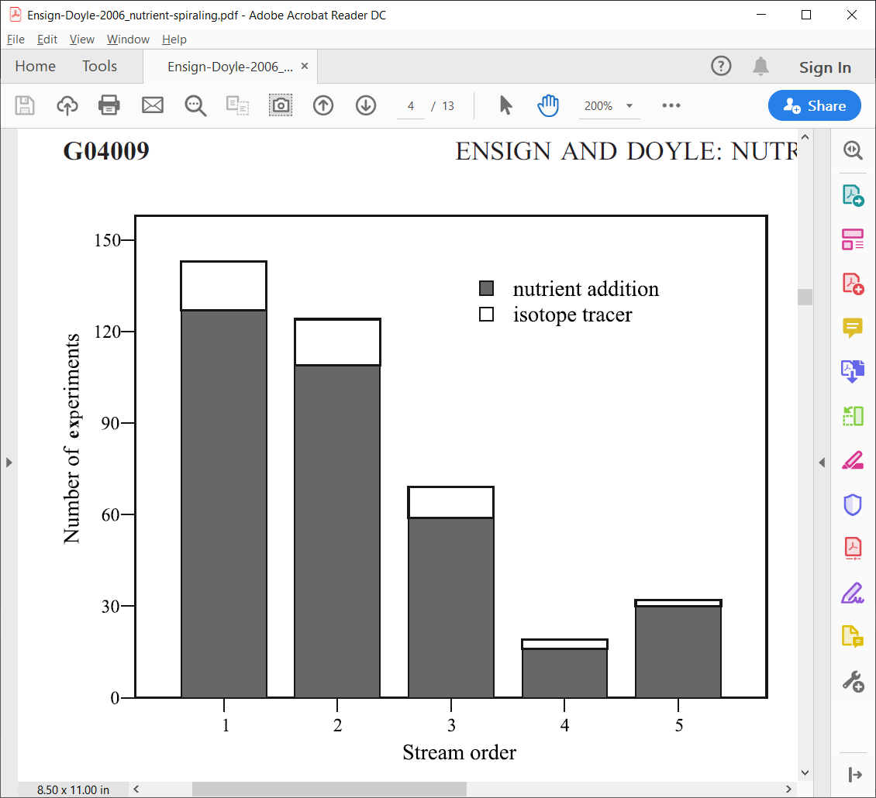

**Figure 1.** Distribution of nutrient spiraling experiments by Strahler stream order (Ensign and Doyle 2006).

Significant differences in nutrient spiraling metrics among stream order were present and *Sw* differed between ammonium and nitrate and nitrate and phosphate. The most robust metric of transient storage was negatively correlated with ammonium uptake, nitrate *Sw* an phosphate *Sw*. Ammonium was had shorter *Sw* in high gradient streams than low; this relationship was reversed for phosphate. The ratio of hydraulic uptake (*SH* see p. 5 for definition) to *Sw* indicated that ammonium and phosphate had shorter spiraling distances than *SH*.

**4. Discussion.**

**4.1 Effects of Study Material on the Summary Results.** Nutrient addition studies could alter the ambient nutrient signatures and introduce legacy nutrients to the stream system—isotope tracer studies are thought to be more reliable.

**4.2. Influence of Geomorphology and Transient Storage on Nutrient Spiraling.** This synthesis did little to elucidate the relationship between transient storage–water connected to the surface flow that is delayed in its downstream transport by a stream feature–and nutrient uptake. The authors suggest that additional stream features should be considered to shed light on this area. Despite the uncertainty, the conceptual relationship of transient storage and nutrients remains sound.

**5. Synthesis: Nutrient Spiraling Through Stream Networks.** “The nutrient spiraling model has served as a unifying paradigm for the examination of flowpaths of water and solutes between terrestrial and fluvial ecosystems.” Using tried and true estimators for channel length, number of channels, and catchment area for each stream order in a network, the spiraling of nutrients in a stream network can be estimated.

**5.1. Recycling of Nutrients Through a Stream Network.** Considering a hypothetical drainage, the authors estimated the number of spirals in ammonium, nitrate, and phosphate. These patterns are summarized by Figure 2 below.

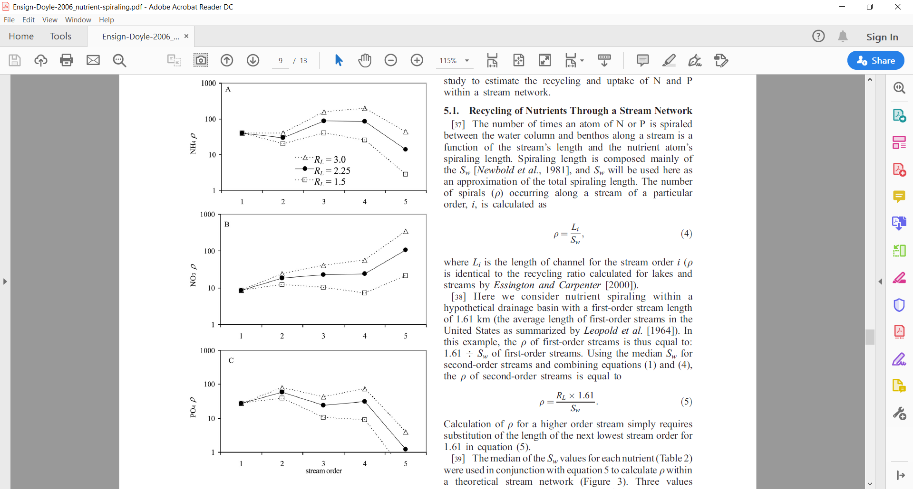

**Figure 2.** Number of (a) ammonium, (b) nitrate, and (c) phosphate spirals undergone within stream orders 1–5 determined using equation (4) and summary values of Sw (Ensign and Doyle 2006).

**5.2. Nutrient Uptake in Stream Networks.** The hypothetical model of Ensign and Doyle (2006) indicates that higher order streams, though fewer in number and total channel area, are just or more important to nutrient spiraling as lower order streams. The results of this paper were consistent with the findings of Wollheim et al. (2006)—more removal (assuming this is denitrification and burial) in high order streams compared to low when uptake is held constant.

**6. Conclusions.** High order streams likely play just as important of a role as lower order streams in nutrient spiraling. Patterns of spiraling vary among ammonium, nitrate, and phosphate while uptake remains constant. Research on stream network nutrient spiraling is needed.

**What needs to be clarified?**

**What were the major findings of this paper?**

**What do you think could be done to strengthen this study?**

**How does the floodplain concept relate to nutrient spiraling?**

**What did the authors not touch on? (Hint: they frame their example under the RCC).**